EXPT NO: 8 | GENERATION OF SYNTHETIC IMAGES USING A GENERATIVE ADVERSARIAL NETWORK (GAN)
DATE: 01/11/2026

PRE-LAB QUESTIONS (PROVIDE BRIEF ANSWERS TO THE FOLLOWING QUESTIONS)

Midhun P 24BAD069

- Discuss the roles of the Generator and Discriminator in a GAN.

The Generator creates synthetic images from random noise vectors. The Discriminator distinguishes real images from generated images. The Generator tries to fool the Discriminator by producing realistic images. The Discriminator learns to identify fake images accurately. Both networks improve through adversarial training.

- Explain how a Generator produces synthetic images from random noise.

The Generator takes a random noise vector as input. It passes the vector through neural network layers to generate an image. During training, it learns patterns and features from real images. These learned features help it produce realistic synthetic images. The quality of the images generally improves as training progresses.

- Why is adversarial training important in a GAN?

Adversarial training enables the Generator and Discriminator to learn through competition. The Generator tries to create realistic images to fool the Discriminator. The Discriminator learns to distinguish real images from fake ones. Their competing objectives help improve the Generator's output. This process continues until training reaches a useful balance.

- Discuss the significance of the loss functions used to train the Generator and Discriminator.

Loss functions measure the performance of the Generator and Discriminator. The Generator loss measures how well it fools the Discriminator. The Discriminator loss measures its ability to classify real and fake images. These losses provide feedback for updating network parameters. They help guide adversarial training and improve image generation.

AIM
To implement and train a Generative Adversarial Network (GAN) to generate synthetic images by training a Generator and a Discriminator in an adversarial learning framework.

SOFTWARE REQUIREMENTS
- Python
- TensorFlow / Keras / PyTorch
- Google Colab
- GitHub
- NumPy
- Matplotlib
- Pandas
- Scikit-learn

OBJECTIVES
Students will be able to:
- Understand the architecture and working of Generative Adversarial Networks.
- Identify the functions of the Generator and Discriminator.
- Prepare image datasets for GAN training.
- Generate random noise vectors as inputs to the Generator.
- Build and train a simple GAN using a suitable dataset.
- Understand adversarial training and the associated loss functions.
- Generate synthetic images and visualize the results.
- Evaluate the quality and diversity of generated images through visual inspection.
- Document the experiment and manage the notebook using GitHub.

PROCEDURE
PART A: DATASET PREPARATION
Perform the following tasks:
- Load an image dataset, such as MNIST, and display sample images.
- Explore the image dimensions and pixel-value range.
- Normalize and reshape the images according to the GAN input requirements.
- Prepare batches of real images for training.
(CODE: CONATAINS STUDENT ROLL NOS
SCREENSHOT OF CODE
SCREENSHOT OF OUTPUT)

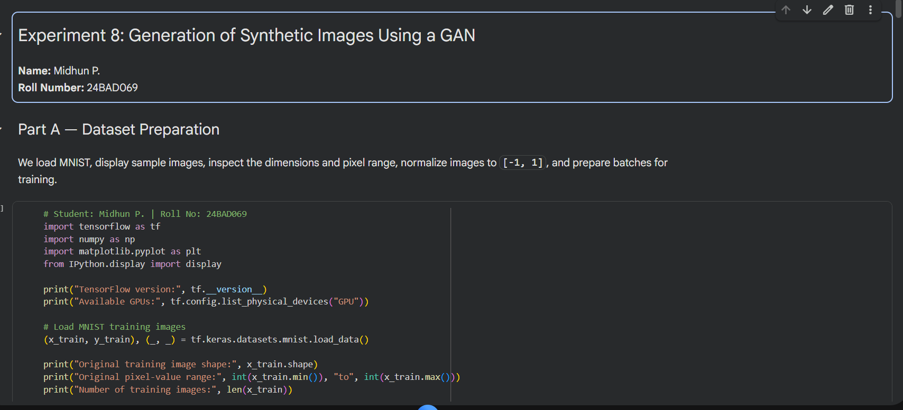
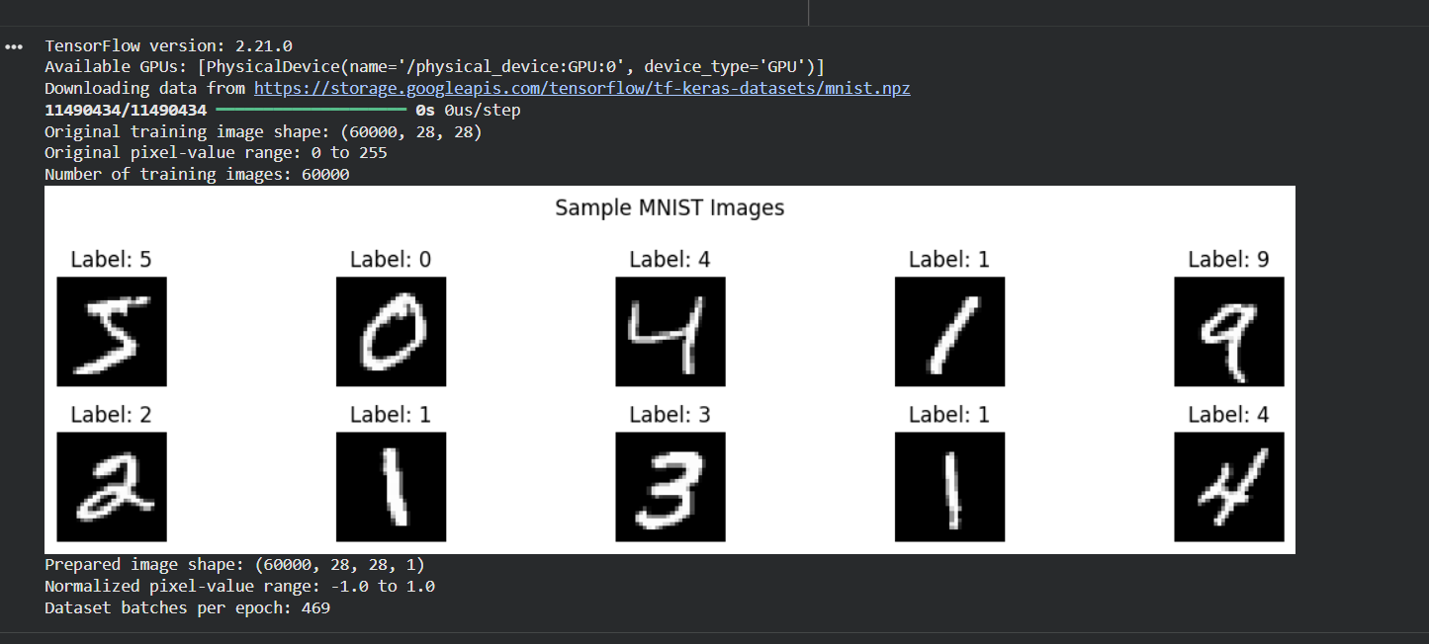

PART B: IMPLEMENTING THE THE GENERATOR AND DISCRIMINATOR
Perform the following tasks:
- Build a Generator model to create synthetic images from random noise vectors.
- Build a Discriminator model to classify images as real or generated.
- Select suitable layers, activation functions, optimizer, and loss function.
- Combine the Generator and Discriminator to construct the GAN.
- Display the model summaries.

(CODE: CONATAINS STUDENT ROLL NOS
SCREENSHOT OF CODE
SCREENSHOT OF OUTPUT)

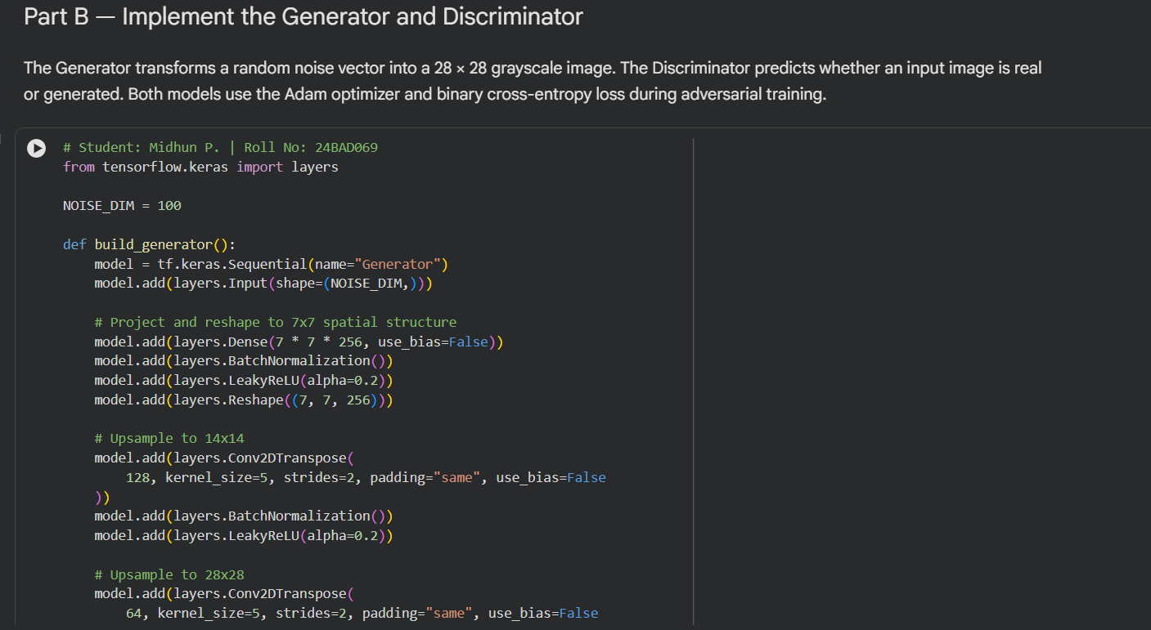
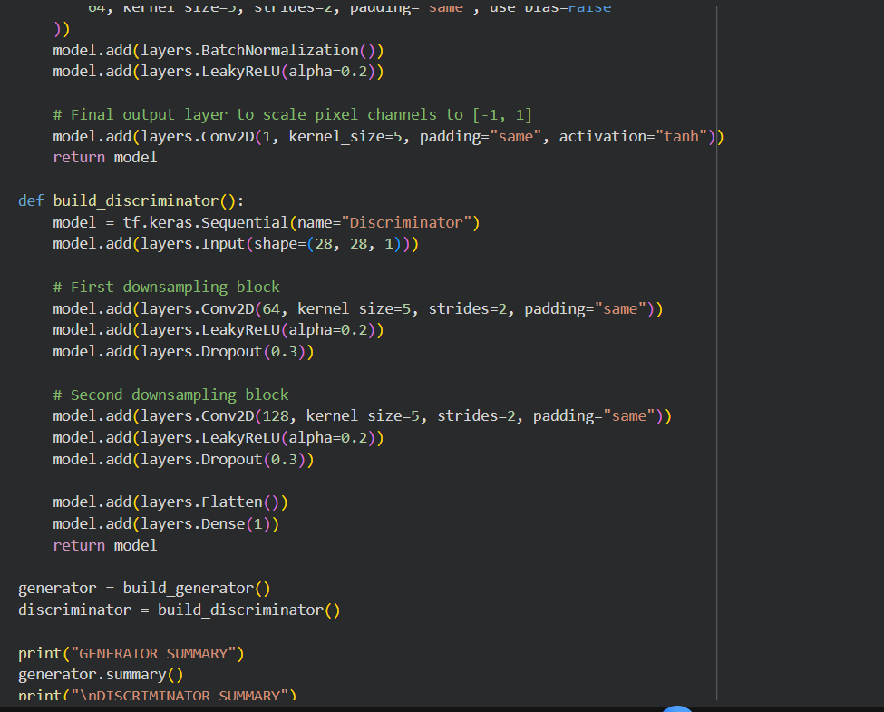
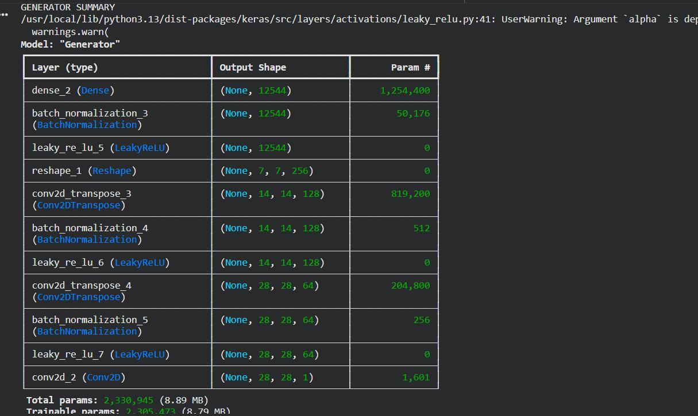
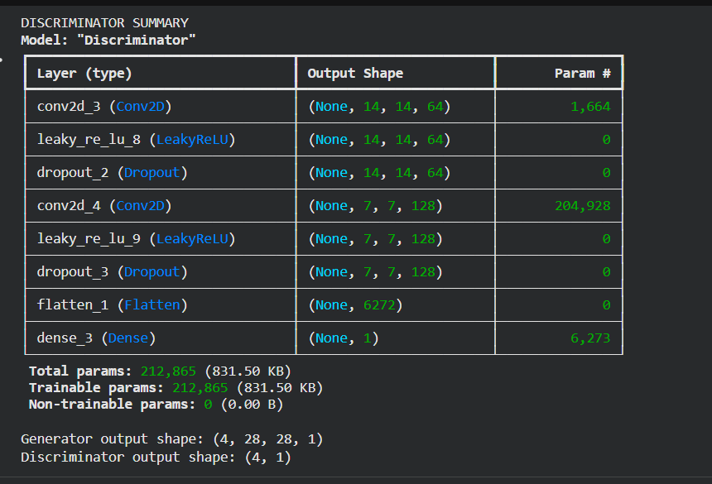

PART C: GAN TRAINING AND PERFORMANCE MONITORING

Perform the following tasks:
- Train the Discriminator using real and generated images.
- Train the Generator to produce realistic images.
- Alternate the training of both models for a suitable number of epochs.
- Record and plot Generator and Discriminator losses.
- Display sample generated images during training.

(CODE: CONATAINS STUDENT ROLL NOS
SCREENSHOT OF CODE
SCREENSHOT OF OUTPUT)

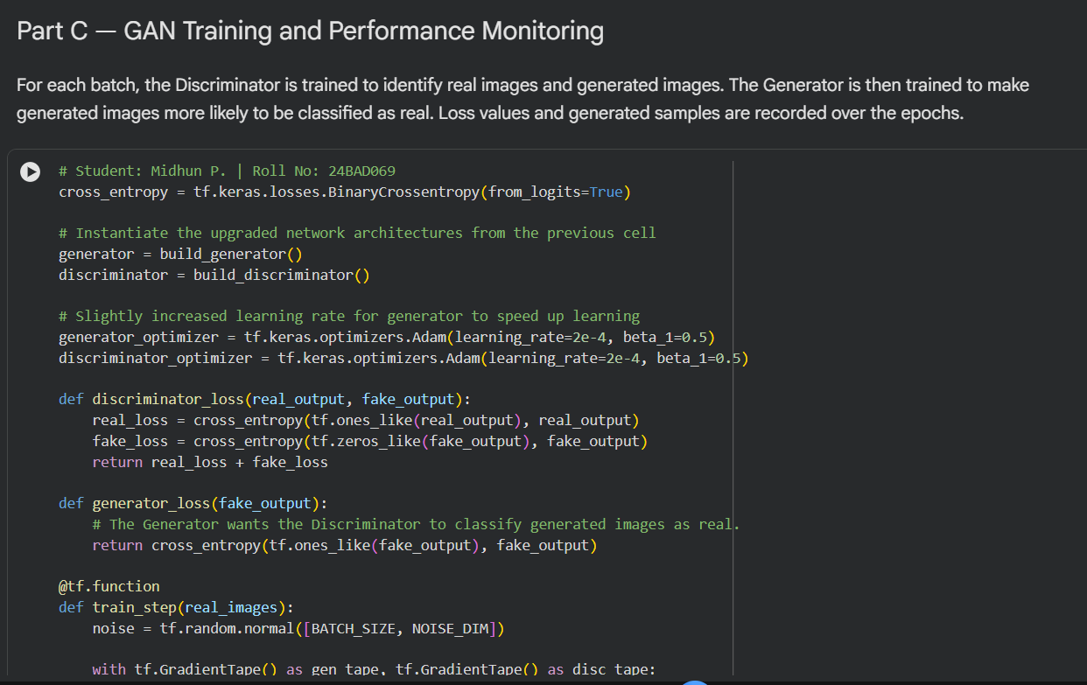
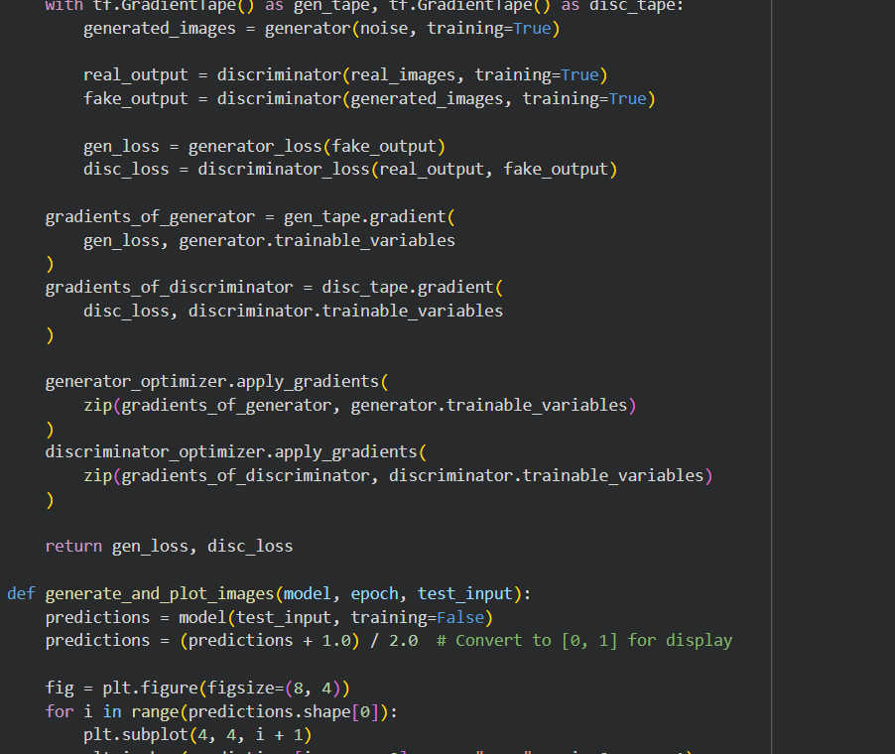
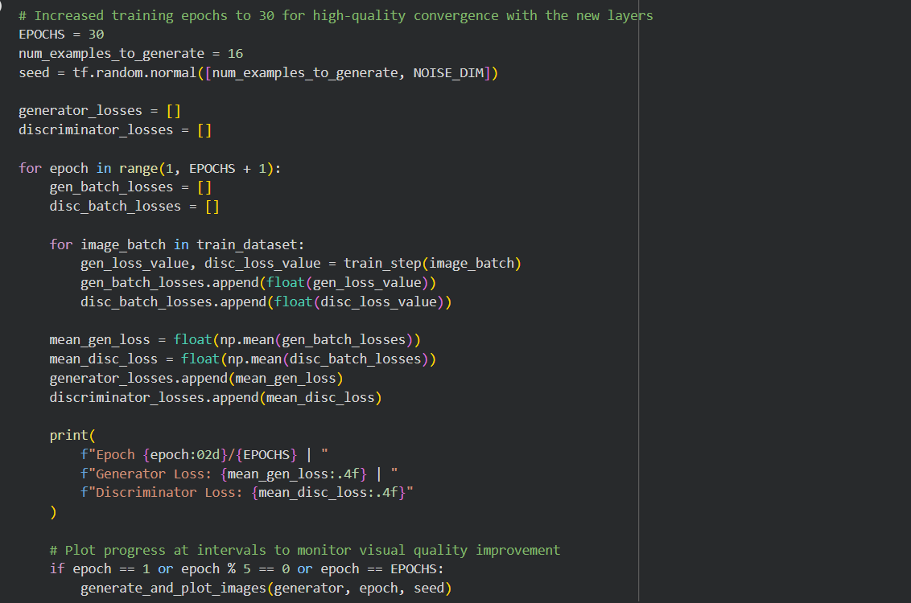
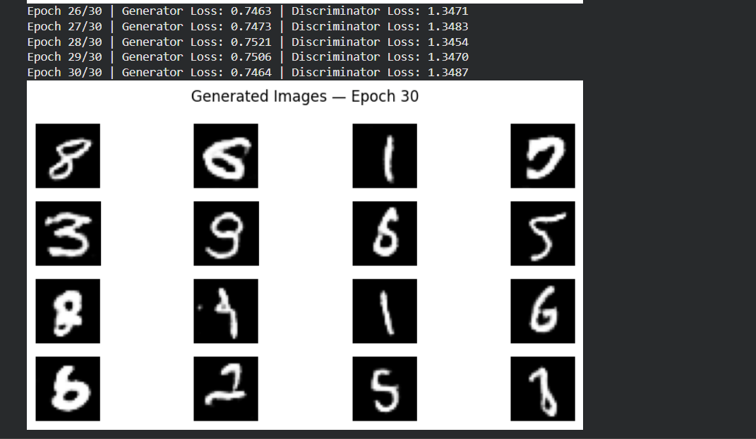
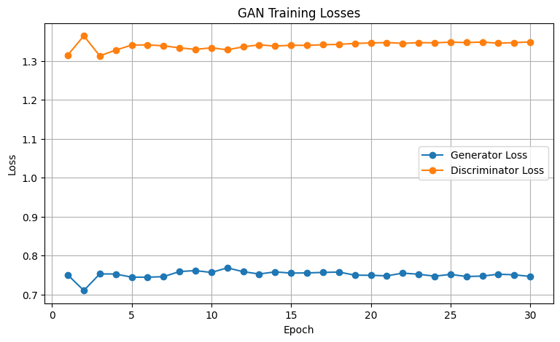

PART D: DIMENSIONALITY REDUCTION, FEATURE VISUALIZATION AND EXPERIMENT MANAGEMENT

Perform the following tasks:
- Provide new movie-review sentences as input to the trained LSTM model.
- Extract latent-space representations of test samples using the trained Encoder.
- Generate synthetic images using the trained Generator.
- Display and compare generated images with original dataset samples.
- Observe the quality, diversity, and recognizability of generated images.
- Document the experiment and upload the notebook to GitHub.

(CODE: CONATAINS STUDENT ROLL NOS
SCREENSHOT OF CODE
SCREENSHOT OF OUTPUT)

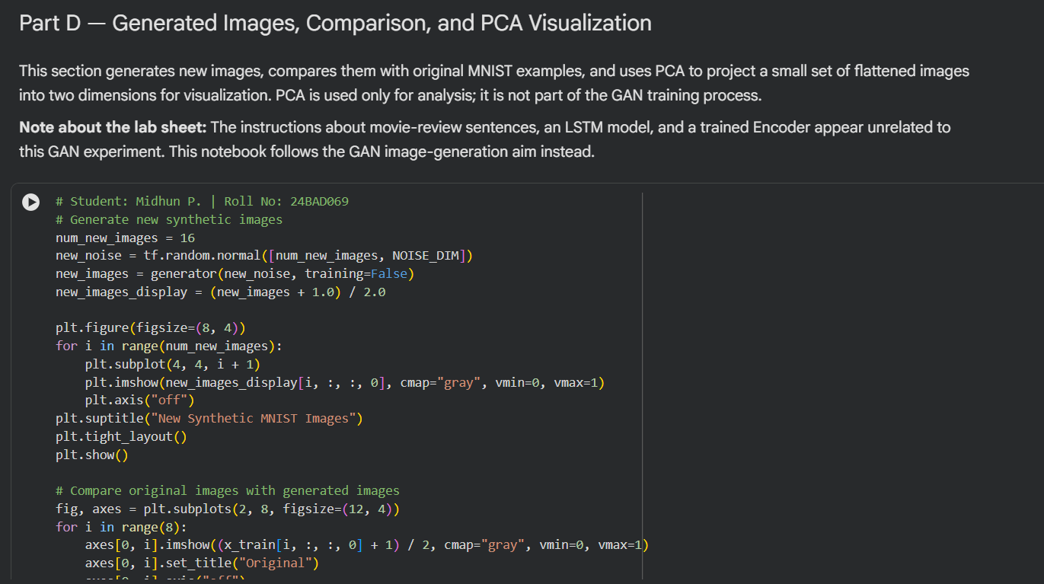
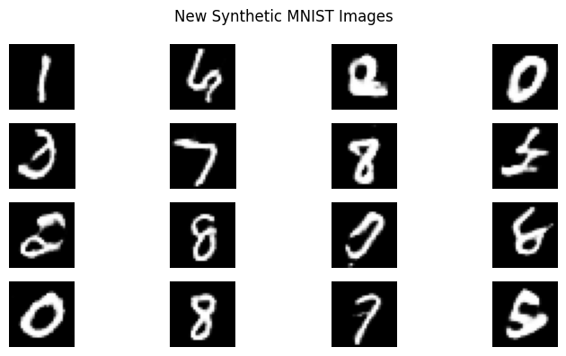

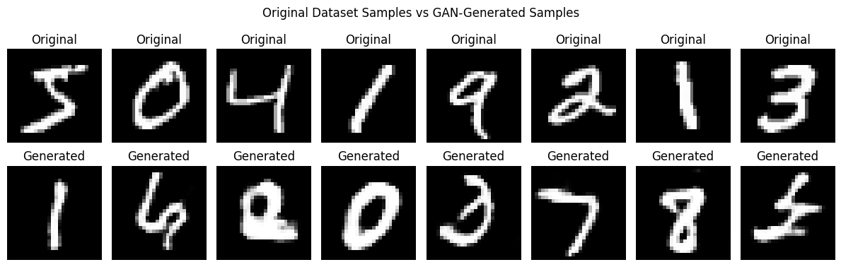

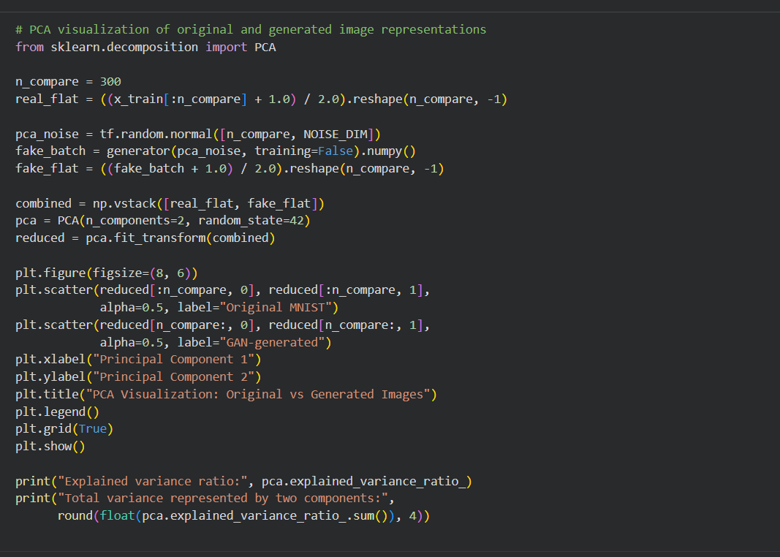
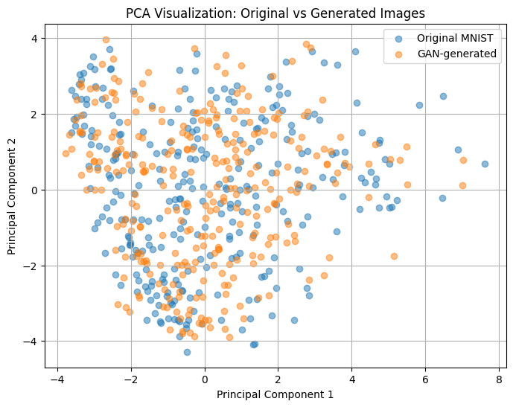
POST-LAB QUESTIONS (PROVIDE BRIEF ANSWERS TO THE FOLLOWING QUESTIONS)

- Discuss how the quality of generated images changes as GAN training progresses. Explain why a GAN may generate repetitive or low-quality images.

Initially, generated images may appear as random noise. As training progresses, the Generator learns patterns and produces recognizable images. However, some images may remain blurry or unrealistic. Mode collapse can cause the Generator to produce repetitive images. Insufficient training and unstable learning can also reduce image quality.

- Differentiate between the Generator loss and the Discriminator loss.

Generator loss measures how well the Generator fools the Discriminator. The Generator attempts to minimize this loss by producing realistic images. Discriminator loss measures how accurately the Discriminator classifies real and fake images. The Discriminator learns to identify real images and reject generated ones. Both losses guide the adversarial training process.

- Discuss two real-world applications of GANs apart from handwritten digit generation.

1. Medical Imaging: GANs can generate synthetic medical images to augment datasets used for medical research and image analysis. This can help when real training images are limited.
2. Image Enhancement: GANs can improve image resolution and restore damaged or blurry images. They learn visual patterns to generate more detailed and realistic results.

ASSESSMENT
Description | Max Marks | Marks Awarded
Pre Lab Exercise | 5
In Lab Exercise | 10
Post Lab Exercise | 5
Viva | 10
Total | 30
Faculty Signature

